

Press Statement: 20 April 2020

**SCOTTISH SCULPTURE PARK JUPITER ARTLAND SHARING EXPERIENCES OF ART AND NATURE DURING LOCKDOWN**

Left: Jupiter Artland at dawn, taken this week by Jupiter’s Keeper of the Landscape Thomas Unterdorfer; centre left: Jupiter Artland in Minecraft; centre right: Peter Liversidge’s THANK YOU NHS, Sign Paintings for the NHS, Courtesy of the artist; right: Rising Residency artists Taahliah and Huss Instagram take-over, Courtesy the artists.

* Jupiter Artland opens virtual sculpture park in **Minecraft**, with young people invited to build proposals for their own sculptures to be added to the online collection
* Andy Goldsworthy, Sara Barker and Shane Waltener among artists sending **Notes from Jupiter**, a series of creative activities for young people to explore at home
* **Peter Liversidge** invites teenagers to share their lockdown stories, incorporating responses into a monumental new Sign Painting to be unveiled at Jupiter Artland later this summer as part of Jupiter Artland’s series dedicated to the legendary artist **Allan Kaprow**
* Artists announced for first **Rising Residency**, powered by Glasgow-platform OH141 and Jupiter Artland to support artists who identify as womxn, person of colour, LBBTQ+ or under-represented communities in the arts

**PETER LIVERSIDGE AND JUPITER ARTLAND LAUNCH OPEN CALL TO TEENAGERS TO SHARE THEIR LOCKDOWN STORIES**

Peter Liversidge invites teenager to share their lockdown stories, incorporating responses into a monumental artwork to be unveiled at Jupiter Artland later this summer. Taking the form of a giant Sign Painting, Liversidge seeks to amplify the voices of young people, providing a snapshot of teenage life under lockdown. This is part of Jupiter Artland’s **Allan Kaprow** project, a series of artist reinventions taking place across Jupiter Artland this summer.

During these strange times, each and every one of us has had to adapt to the new world that Covid-19 has created. This summer, Jupiter Artland has invited Scottish and international artists to reinvent artworks from Allan Kaprow’s career, reimagining them for our extraordinary current moment and our new shared reality.  
  
To begin the series, **Peter Liversidge**is reinventing Allan Kaprow's *Out*, first created for Edinburgh in 1963 and reimagined by Liversidge for Edinburgh 2020. As we observe social-distancing, Liversidge is extending an **open call**to all young people in the UK to join him in creating a new artwork to be unveiled at Jupiter Artland later this summer. Liversidge wants to know what’s on your mind and is gathering responses from people, especially those under the age of 20, to be incorporated into a monumental sign painting. A collaboration with Jupiter’s ORBIT Youth Council, to get involved, answer this short [questionnaire](https://www.surveymonkey.co.uk/r/DHX7PY3) or check out our next [**Notes from Jupiter**](https://www.jupiterartland.org/notes-from-jupiter) for creative activities for the family to explore at home.

American artist Allan Kaprow (1927 – 2006) has been described as an avant-garde revolutionary, a radical sociologist, a progressive educator and one of the most influential artists of his day. Known for his ‘Happenings’, Kaprow coined the term to describe his anarchic gatherings in 1960s New York, in which the audience became participants. He was an early pioneer of using telephones to connect remote participants, and for creating ‘Activity Booklets’, simple instructions or ‘scores’ for artworks that could be undertaken by people privately within their own homes, believing that “[art] is for all beings, but in actual practice it is available for those who seek it out: the artist and a few friends. And maybe that’s okay.”

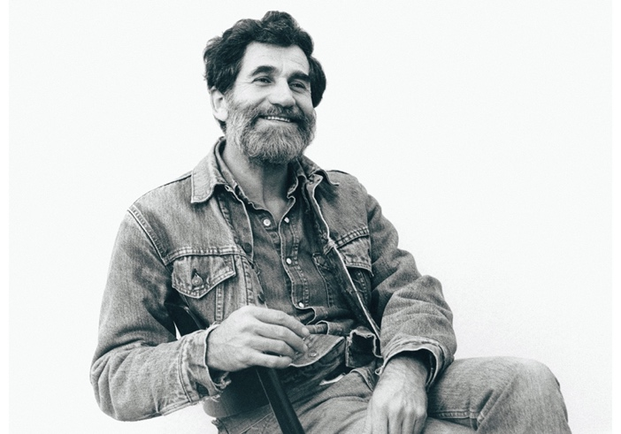

Left: Photo of Allan Kaprow courtesy the Estate of Allan Kaprow and Hauser & Wirth. Right. Sign Paintings for Stockholm, Peter Liversidge, Courtesy the artist.

Artists **Andrea Büttner**, **James Hoff** and **Cinzia Mutigli** have also been commissioned by Jupiter Artland to reinvent works by Allan Kaprow, reimagining them according to the new reality covid-19 has created. Outdoor artworks, including Peter Liversidge’s monumental sign painting, will be open to the public to view once Jupiter Artland reopens later this summer. The re-opening date will be announced in-line with Government guidelines.

Quote from: *Allan Kaprow: 7 Environments*, 1992, p. 26.

**JUPITER ARTLAND OPENS VIRTUAL SCULPTURE PARK IN MINECRAFT**

Jupiter Artland today (20 April) launches virtual sculpture park in Minecraft as an open source platform for young people to visit and explore during lockdown. Young people can also build their own proposal for a sculptural artwork, with the winning design becoming a permanent addition to the acclaimed Scottish sculpture park’s virtual landscape.

Director of Jupiter Artland **Nicky Wilson** says: “We are thrilled to be able offer people a little slice of Jupiter magic, especially now as parents face increased pressure with home-schooling. Jupiter Artland in Minecraft is quite remarkable – much cherished artworks by Antony Gormley, Anya Gallaccio, Tania Kovats and Charles Jencks have been lovingly recreated. As Minecraft is a familiar and popular platform for children, it provides a safe space to learn about art.”

Left: Easter Egg Hunt at Jupiter Artland in Minecraft. Right: Participant in the Easter Egg Hunt builds tribute to the NHS at Jupiter Artland in Minecraft

The first generation of Jupiter Artland in Minecraft has previously only been accessible for visitors physically on-site at the award-winning sculpture park just outside Edinburgh. This newest generation is available everywhere, allowing audiences across the globe, both young and old, to explore, discover and create. Jupiter Artland in Minecraft is a collaboration with Edinburgh Napier University’s Centre for Interaction Design, who continue to work with Jupiter to develop new platforms for exploring art, ideas and nature. This Easter, to test the software, Jupiter Artland hosted an Easter Egg Hunt, with over 100 young people logging on to the game, following clues to discover digital eggs hidden across the park.

Claire Feeley from Jupiter Artland says: “Young people have remarkable digital skills. Once all the eggs were found, children began building their own wonderful looking creations opposite Jupiter Artland’s front gates using Minecraft tools. One rainbow-coloured tower celebrated the NHS and others took the form of bunny rabbits, daffodils and proposals for impossible buildings. We look forward to seeing the outcome of the ‘design a sculpture’ competition.”

A new challenge has been launched today, inviting young people to design and build their own sculpture, with the winning design becoming a permanent feature of the landscape at Jupiter. To take part, visit [www.jupiterartland.org](http://www.jupiterartland.org)

**ANDY GOLDSWORTHY, SARA BARKER AND SHANE WALTENER AMONG ARTISTS TO SHARE ‘NOTES FROM JUPITER’, A SERIES OF CREATIVE ACTIVITIES FOR YOUNG PEOPLE TO EXPLORE AT HOME**

Left: Notes from Jupiter, creative activities inspired by Scottish and international artists. Right: portrait of Scottish artist Andy Goldsworthy, courtesy the artist.

Artists including **Andy Goldsworthy**, **Sara Barker**, **Peter Liversidge** and **Shane Waltener** among the first to share **Notes from Jupiter**, a weekly creative challenge, make-and-do project or reflective activity for young people and parents to explore together at home during lockdown.

Glasgow-based sculptor **Sara Barker** was the first artist to send her ‘**Notes from Jupiter’**, sharing a tower-building project inspired by her permanent artwork at Jupiter Artland. From his garden studio in Essex, textile artist and sculptor **Shane Waltener** invited people to see the world around them anew, by creating viewfinders that frame unexpected views and draw attention to the overlooked. Each week, a new ‘**Notes from Jupiter’** will be shared by the Edinburgh-based sculpture park through social media and their website.

Director of Jupiter Artland **Nicky Wilson** comments: “During these unusual times, our aim that every child in Scotland counts becomes even more important, as families and children need more support and inspiration whilst working from home and home-schooling. We are working even harder to support parents, teachers and young people to build a life-long appreciation of art by developing Notes from Jupiter, bringing you a little slice of Jupiter magic direct to your inbox each week.”

**ARTISTS ANNOUNCED FOR FIRST RISING RESIDENCY, POWERED BY GLASGOW-PLATFORM OH141 AND JUPITER ARTLAND TO SUPPORT ARTISTS FROM UNDER-REPRESENTED GROUPS, AND CONTINUES ONLINE DURING LOCKDOWN.**

**Farah Hussain**, **Ryan Miller**, **Chanelle Brown** and **TAAHLIAH & HUSS** have been announced as the first artists to participate in the inaugural Rising Residency. Linked to Jupiter Artland’s annual festival Jupiter Rising, the residency has been created by Jupiter with OH141, a Glasgow-based collective born of the clubbing scene, who champion and advocate on behalf of underrepresented groups in art and music, particularly Scottish-based emerging artists who identify as womxn, a person of colour or LGBTQ+.

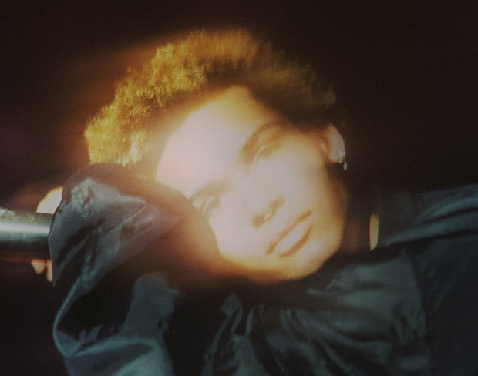

Left: TAAHLIAH announced as one of five artists participating in the Rising Residency, alongside her collaborator HUSS. Photo credit: Cynthia Ammann; Right: Furmaan Ahmed, part of the judging panel for the award.

Speaking on the selection process, panellist **Furmaan Ahmed** said: “I think it is easy to get used to seeing the same names, the same formats and the same circle of artists creating and being given very public platforms from the same institutions (people coming from art schools). This selection was definitely an eye opener to me in terms of the vast quality of really valuable voices that do need platforms and to be supported. I really didn't know what to expect but I was quite blown away at how many strong artists with such strong voices had applied from all walks of life.” Other esteemed panellists include artist, researcher and curator Alberta Whittle, artist and curator Andrew Sim, events organiser and OH141 co-founder Sarra Wild, Nicky Wilson, Director of Jupiter Artland, and Claire Feeley, Head of Exhibitions and curator of Jupiter Rising festival.

Glasgow-based artist and poet **Chanelle Brown's** multi-sensory landscapes rewrite and unravel history beneath layers of hair, textiles, rhyme and moving image. 'The Rising Residency represents a new beginning for me,' she explains. 'In this time of quarantine, I have said goodbye to things and people that I love, I am learning about boundaries by social-distancing, and I am understanding self-love and community in new ways by self-isolating.'

**Farah Hussain**, who is currently studying in Dundee, explores her own experience, touching upon themes of religion, drag, club culture and utopian worlds. Since graduating from art school, **Ryan Miller**'s work has moved to a more botanical medium, with the artist having recently set up a florist business with the help of The Prince's Trust. 'I have a great interest in the outdoors and living in the wilderness,' he says. 'I hope the work I create will engage directly with the landscape, responding to notions of conservation, ecology, and sustainability of Scotland.

Performance artist, producer and **DJ TAAHLIAH** and Middle Eastern, Glasgow-based artist **HUSS** will be working collaboratively on a project as part of the Rising Residency. TAAHLIAH's musical productions express a societal ideal of fluidity in line with different debates she animates across her city's cultural sector, while HUSS uses performance art to investigate concepts such as his own identity, his personal experiences with racism, ethnocentrism and xenophobic behaviours.

'I think it's fabulous that, as artists who inhabit an identity that some would consider as a minority, we are being provided with this space and artistic freedom to create one-off special pieces of work.' TAAHLIAH notes. 'I'm very excited for this residency,' HUSS continues, 'as not only is it giving me the opportunity to collaborate and work around people that inspire me very much, it also gives an opportunity to use this platform to speak up about important issues we are facing and issues I feel entrapped by.'

**Nicky Wilson**, Director of Jupiter Artland, said: 'Without doubt the Jupiter Rising Residency is the single most important engagement project we do at Jupiter. To speak truth and examine society without flinching needs to be supported and enabled and in return we are nourished by the fresh thinking and enquiry. It's a good partnership and these artists are people to watch out for.'

**ENDS**

**For further information, high res images and to arrange interviews please contact:**

Eleanor Edmondson at email [eleanor@jupiterartland.org](mailto:eleanor@jupiterartland.org)

Images: <https://drive.google.com/drive/u/0/folders/1Z7F2Y_O1Kgi7h2yHUioG_58O856ek4wB>​

**LISTINGS**

**Location:** Jupiter Artland, Wilkieston, Edinburgh EH27 8BY

**W:** [www.jupiterartland.org](http://www.jupiterartland.org)

**Instagram:** [@jupiterartland](https://www.instagram.com/jupiterartland/?hl=en)

**Twitter:** [@jupiterartland](https://twitter.com/jupiterartland?ref_src=twsrc%5Egoogle%7Ctwcamp%5Eserp%7Ctwgr%5Eauthor)

Jupiter Artland will remain closed whilst we continue to observe social distancing. The opening date of Jupiter Artland’s outdoor spaces, including the unveiling of Peter Liversidge’s new artwork, will be announced in due course in-line with government guidelines.

**Notes to Editors**

**Jupiter Artland Foundation** is one of Scotland’s most significant arts organisations, with five gallery spaces and an expansive outdoor sculpture collection, featuring landscaped gardens and site-specific commissioned artworks from some of the world's most significant artists. Located just outside Edinburgh, Jupiter Artland is a registered charity, founded by the philanthropist art collectors Robert and Nicky Wilson, now with 36 permanent site-specific works across 100 acres of woodland and meadows. Committed to nurturing the work of outstanding contemporary artists and continuing to commission new works to grow the ever-evolving landscape, Jupiter Artland opened to the public in May 2009, and in 2016 was nominated for the Art Fund’s prize for Museum of the Year.

Permanent sculptures and installations across the grounds include works by artists including Antony Gormley, Charles Jencks, Anish Kapoor, Christian Boltanski, Joana Vasconcelos, Nathan Coley, Ian Hamilton Finlay, Laura Ford, Anya Gallaccio, Andy Goldsworthy, Jim Lambie, Cornelia Parker and Marc Quinn. Each artwork’s specific site has been personally selected by the artist. The works are set within the grounds of Bonnington House, a 17th century Jacobean Manor House and visitors are encouraged to freely explore the Artland and discover the artworks at their own pace.

Jupiter Artland’s ground-breaking learning programme includes free visits for nurseries, schools, universities and community education organisations. Since the programme began in 2009 over 20,000 learners have been welcomed to the collection as part of free or subsidised visits. Jupiter Artland’s child-led ethos to learning sparks curiosity and builds resilience, creativity and critical thinking skills in the minds of young learners. Jupiter Artland’s mission is for every school child in Scotland to visit or experience Jupiter Artland either through a visit with hands-on activity or through Jupiter Artland’s pioneering digital projects.