CURATORS AND LINE-UP ANNOUNCED FOR JUPITER RISING FESTIVAL

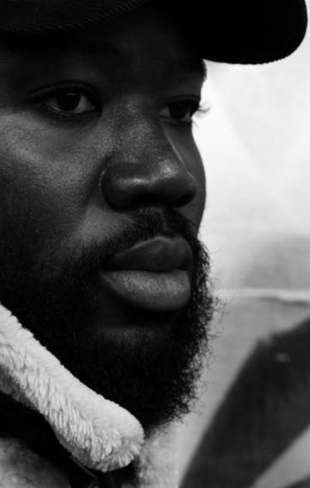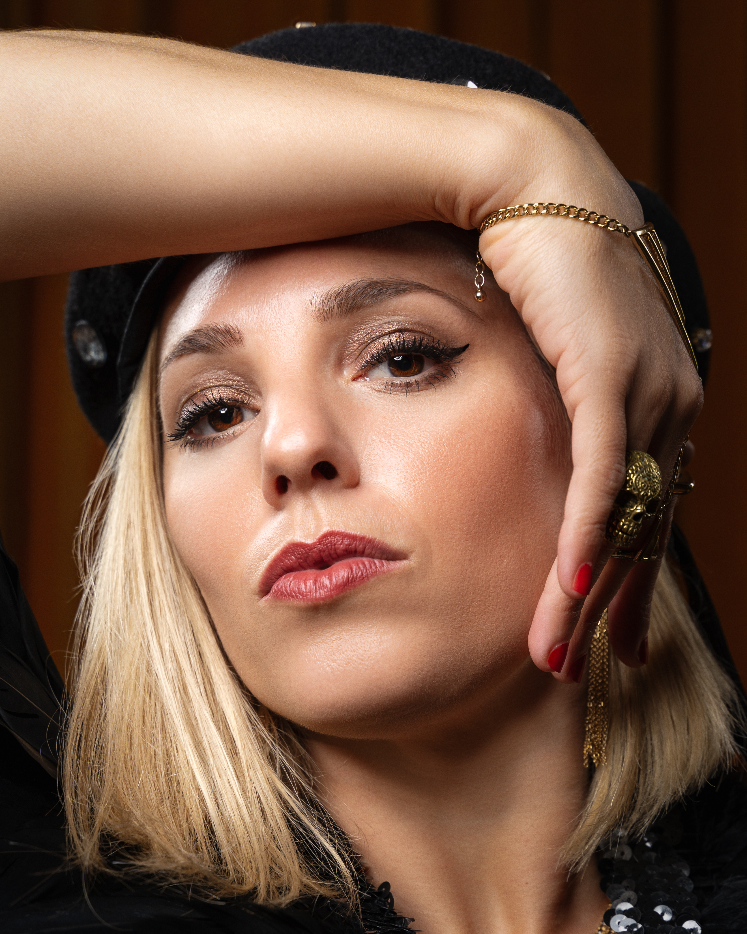
Alloysious Massaquoi photo © Mustafa Sarwarr; Tamara Schlesinger photo © Curse These Eyes.

- Young Fathers’ Alloysious Massaquoi is revealed today as Guest Curator for JUPITER RISING festival, which will take place at Jupiter Artland from 26 to 28 August 2022.

- Hen Hoose will join Massaquoi as second Guest Curator, the Glasgow-based collective making waves bringing gender equality to the music industry.

- Artists for JUPITER RISING 2022 line-up include AMUNDA, Dean Rodney Jr, Distruction Boyz, Djana Gabrielle, Dylema Collective, Emma Pollock, Jayda, MALKA, Mychelle, Poster Paints and Susan Bear.

JUPITER RISING, 26 to 28 August 2022
Jupiter Artland Edinburgh, EH27 8BY
Tickets available at www.jupiterrising.art
For Press, contact eleanor@jupiterartland.org
Full Image Bank: Image bank

JUPITER RISING, Scotland’s artist-led outdoor festival for art, music and performance has today (10 March 2022) announced Young Fathers Alloysious Massaquoi and Hen Hoose’s Tamara Schlesinger as Guest Curators for the 2022 festival. JUPITER RISING is a two-night campout festival running 26 to 28 August 2022, in the iconic landscape of Jupiter Artland, home to a world-class collection of outdoor artworks and landforms. A firmly independent and artist-driven festival, JUPITER RISING invites audiences to explore, discover and celebrate exciting new music, artist-happenings and forward-thinking panel discussions, alongside established international acts delivering punchy festival vibes.

Artists included in the first line-up announcement include South African duo Distruction Boyz, the soul jazz pioneer Dylema, rising star Mychelle, the invincible Dean Rodney Jr and Scottish all-stars Emma Pollock, MALKA, AMUNDA, Poster Paints, Susan Bear, Jayda and Djana Gabrielle. With an audience capacity of just 1000 people, and a strong emphasis on championing diversity, JUPITER RISING has rapidly established a reputation as an essential player in breathing new life, energy and progressive politics into the festival format.

Alloysious Massaquoi, one third of Mercury Prize-winning Young Fathers, is one of the most influential artists in the Scottish music scene. Young Fathers produce music which spans genres and defies catagorisation, always pushing artistic boundaries whilst delivering consistently awe-inspiring records, an ethos matching that of Jupiter Rising. Alloysious’ line-up for the Edinburgh-based camping festival includes some of the most adventurous artists working across spoken word, dance, performance, soul and house music, from the driving rhythms of gqom phenomenon Distruction Boyz to the politically charged anthems of Dylema Collective.

Alloysious Massaquoi shares his excitement for the festival, asking audiences to come ready “I’m excited for the crowd to experience the creative work of the artists I’ve chosen. My advice to them is: come ready, be open & take a chance.”

Hen Hoose are an all female and non-binary songwriting collective, founded by Tamara Schlesinger, with a mission to take a stand against gender inequality in the music sector. The collective has seen some of the finest female and non-binary songwriters and producers in Scotland come together to work collaboratively, releasing their debut album Equaliser to five star reviews and the highest of critical acclaim. Live music took a blow during the pandemic, with female and non-binary artists disproportionally impacted as a result of pre-existing biases in the sector. In the midst of this uncertainty, Hen Hoose grew as a gender non-conforming collective championing community, connection with an inspirationally talented group of artists at its core.

Tamara Schlesinger shares her plans for JUPITER RISING 2022, saying ‘I am delighted to have been invited to co-curate Jupiter Rising this year. We are taking this opportunity to highlight some incredibly talented female and non-binary artists in Scotland. It feels refreshing to be involved in putting together such a diverse and gender balanced line up at a festival.’

Described as ‘expertly curatred’ and ‘giving us a glimpse of what Scotland’s festivals should and could be in terms of inclusivity and diversity’, JUPITER RISING has swiftly gained a loyal fanbase, and with only 1000 tickets available, it’s an event not to be missed. As an artist-driven festival, the event can be charmingly idiosyncratic, with every aspect of the stages, tents, bars and all-ages area built, programmed, curated and cared-for by artists that pour their creative energy into every aspect. It’s a place where you’ll likely stand shoulder to shoulder at the bar with the artist about to headline the mainstage, and indeed artists make up a large proportion of the audience, reflecting the values of Jupiter Artland who founded the festival as a core part of their year-round artistic programme dedicated to supporting artists at all stages of their careers and reflecting the real diversity of artistic talent in the nation.

Past performers at JUPITER RISING have included The Comet is Coming, Cate Le Bon, Sacred Paws, Fimber Bravo, Elaine Mitchener, Nova, Aisha Mirza, Sarra Wild, Ain Bailey and Karen Gwyer. Co-curated by Alloysious Massaquoi, Hen Hoose and the Jupiter Artland team, audiences for JUPITER RISING 2022 can expect an inventive line-up across live music, sound and artist-happenings day and night, talks, discussions and workshops for all-ages, local food and feasting and late night woodland stage.

Early Bird Tickets sold out. General Release Tickets available now starting at £95 including 2-nights camping.

ENDS
Hi-res images can be downloaded here.
For further information, high res images and to arrange interviews please contact: Eleanor eleanor@jupiterartland.org or call 01506 889900

LISTINGS
JUPITER RISING
Dates: Friday 26 August 2022 at 14:00 to Sunday 28 August 2022 at 12:00
Location: Jupiter Artland, Edinburgh EH27 8BY
Campsite located in the paddock, close to the amenities. Bring your own tent.
Tickets: Early Bird £65. £95 full weekend admission; children 12 and under free
Pay What You Can ticket options available. Refugees Welcome. Carers Go Free.

Website: www.jupiterrising.art
Instagram: @JupiterRising_fest
Facebook: https://www.facebook.com/jupiterrising.art
Twitter: @_jupiterrising
#JupiterRising22

NOTES TO EDITORS

About Alloysious Massaquoi
Alloysious Massaquoi is an artist working across mediums from film, composing, acting, vocals, recording and performing. He is a member of award-winning, internationally recognised Scotland based band Young Fathers. Awards include Mercury Prize 2014 for DEAD and Young Fathers are the first band to win two Scottish Album of the Year awards in 2013 with Tape Two and 2018 for Cocoa Sugar. Alongside this Alloysious was nominated for UK Music Video Awards 2018, winning Best Artist.

About Hen Hoose
Hen Hoose was formed by Tamara Schlesinger (MALKA, 6 Day Riot) during lockdown as a response to the gender inequality in the music industry. The Collective has seen some of the finest female and non-binary songwriters and producers in Scotland come together to work collaboratively during what has been an incredibly difficult time for us all. They have secured sync work for ScotGov Vaccines Campaign and recent Caorunn Gin TVC, while project founder Schlesinger was named as an honouree in the 2021 Alternative Power 100 Music List. The collectives debut album Equaliser also came to the attention of Yoko Ono and the John Lennon Foundation. Ono and Sean Lennon selected only 25 charity music organisations in the UK to receive an incredibly rare limited acetate pressing of John Lennon & Yoko Ono’s iconic single ‘Happy Xmas (War is Over)’.
@Hen_Hoose
www.henhoose.com

About JUPITER RISING
JUPITER RISING is led by Jupiter Artland and borne out of the success of ROMANTI-CRASH! in 2018 and LUNARNOVA CAMPOUT in 2017. Taking place within the unique context of Jupiter Artland, the festival invites audiences to explore, discover and celebrate underground and DIY practice alongside established and international artists.

ABOUT JUPITER ARTLAND
Jupiter Artland is one of Scotland’s most significant arts organisations, with five gallery spaces and an expansive outdoor sculpture collection, featuring landscaped gardens and site-specific commissioned artworks from some of the world's most significant artists. 2022 sees the unveiling of a new permanent artwork by Tracey Emin as well as a solo exhibition across the indoor gallery spaces. Jupiter Artland’s ground-breaking learning programme includes free visits for nurseries, schools, universities and community groups. Jupiter Artland’s human-centred ethos to art sparks curiosity and builds resilience, creativity and critical thinking skills in the minds of young learners.

Press quotes:
“Like a festooned Tellytubbyland, the picture is more than a little whimsical. But a dead-eyed, cultrally anemic boutique festival of pleasantries this is not”
The Wire, 2021

“A rejuvenating weekend at Jupiter Rising gives us a glimpse of what Scotland's festivals should and could be like in terms of inclusivity and diversity”
The Skinny, 2021

“A weekend embedded in riot grrrl punk, experimental ambience and forward-thinking workshops; Jupiter Rising is in its essence futuristic, artists reimagining music, workshops dedicated to self-help and mental wellbeing, voicing platforms for marginalized groups, specifically queer-folk and people of colour. It feels that even in its youth, this festival is an essential player in preserving, expanding and celebrating Scottish culture and arts.”
The Skinny, 2019

“Jupiter Rising must continue to champion the art and music at the fringes, the kind you’ll find in DIY spaces run by queer, anti-capitalist and POC groups — from Glasgow and beyond — who’ve long fought to see themselves represented in their industry. Who knows — they might even be the ones responsible for rebuilding it altogether.”
Loud & Quiet, 2019

